What is Junior LandCare?
Junior LandCare is part of the LandCare programme which is designed to empower South African youth, particularly those in rural areas. The programme seeks to address issues of youth unemployment, skills development, school nutrition and environmental education.
Junior Care has two dimensions: In-school Junior Care and Out-of-school Junior Care. In-school Junior Care focus on capacity building and awareness by supporting schools by implementing permaculture gardens, nurseries for greening and camping, etc., while Out-of-school Junior Care focus primarily on unemployed matriculated and agricultural graduates up to the age of 35. The involvement within Out-of-school Junior Care can be through being a beneficiary of a LandCare project, a member of the local LandCare committee, a member of the environmental club/s and also as a young agricultural entrepreneur (farmer).
IN-SCHOOL JUNIOR CARE ACTIVITIES:
The following activities can be implemented or performed for In-school Junior LandCare:
- School gardening
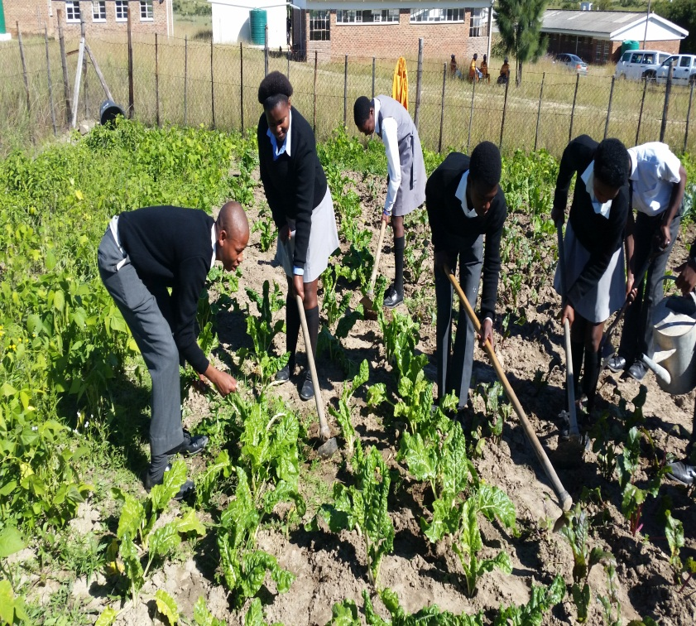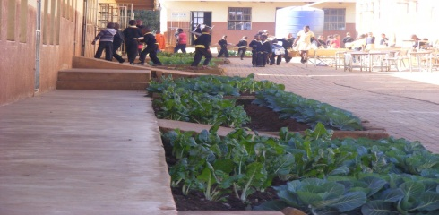

- Awareness, e.g., drama, poetry and songs
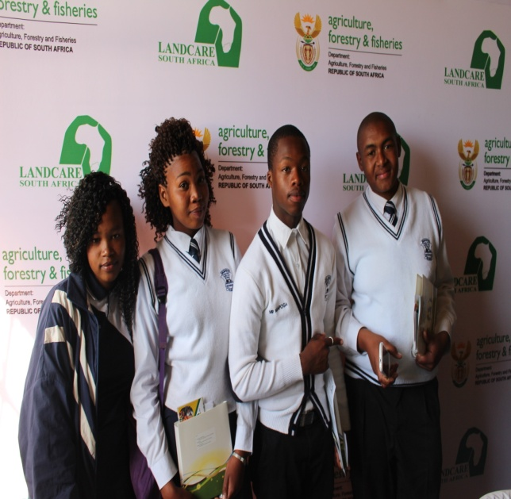

- School camps
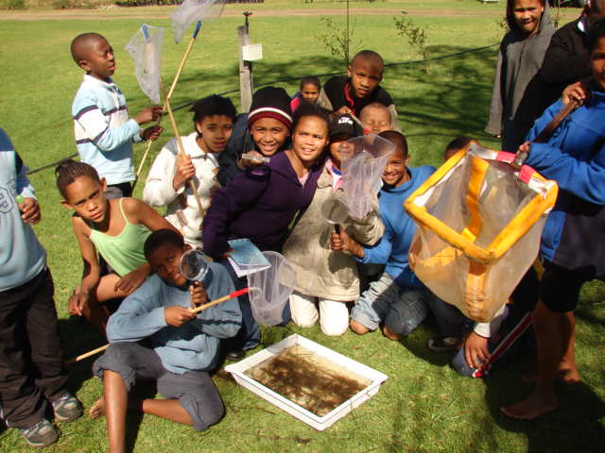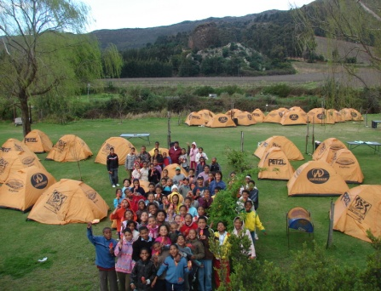
- Puppet shows
The typical skills below can be accessed by the learners (Grade 8-12) through the LandCare programme by the implementation of projects within the Junior Care focus area: In-school Junior Care
  - Permaculture skills
  - Nursery establishment skills
  - Poster development skills
  - Debate skills
  - Drama
  - Speech
  - Life skills.
OUT-OF-SCHOOL JUNIOR CARE ACTIVITIES:
You can become part of Out-of school Junior LandCare through:

- Being a member of the LandCare youth club
- Being member of a LandCare committee
- Being an indirect beneficiary of the LandCare Project through the Extended Public Works Programme
- Being a direct beneficiary – through entrepreneurship (as young farmer).
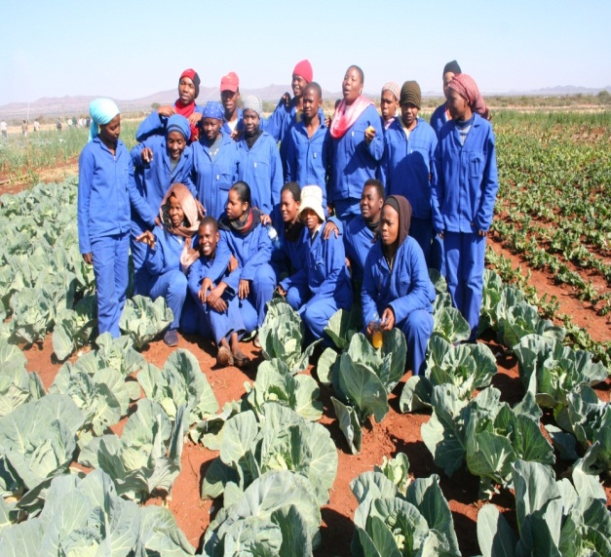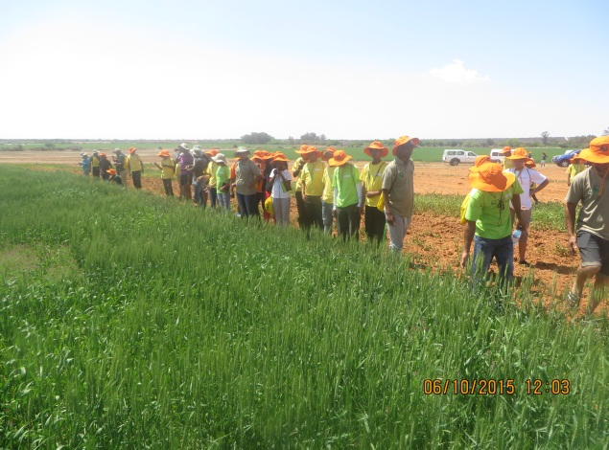
The typical skills below can be accessed by the unemployed youth through the LandCare programme by the implementation of projects within the JuniorCare focus area: Out-of-school

- Conservation Agriculture
- Fence construction skills
- Gabion construction skills
- Alien identification and control skills
- Fire-fighting skills
- Project management skills
- Health and safety skills
- Project management skills
- Mixed farming skills
- Plant production
- Entrepreneurial skills.

Skills can be accessed for both In-school (Grade 8-12 learners) and Out-of-school (unemployed youth) through the following:

- Learners can participate in a Junior Care project in a particular school
- Unemployed youth can participate in community LandCare projects, environmental clubs or natural resources management committees.

The LandCare Secretariat may be contacted for any enquiries and partnerships development:
CONTACT DETAILS
Directorate :Land Use and Soil Management
Tel no. :012 319 7656/012 319 7687
Email :LydiaB@daff.gov.za
NO CARE LANDCARE

